1- How many DaemonSets are created in the cluster in all namespaces?

**kubectl get daemonsets --all-namespaces**



2- what DaemonSets exist on the kube-system namespace?

**kubectl get daemonsets -n kube-system**

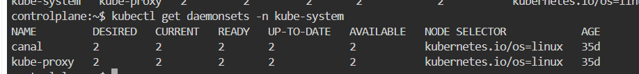

3- What is the image used by the POD deployed by the kube-proxy DaemonSet

**kubectl get daemonset kube-proxy -n kube-system -o yaml | grep image**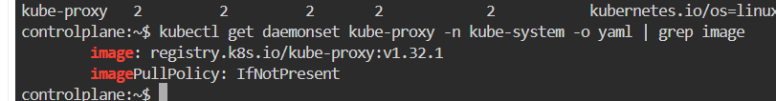

4- Deploy a DaemonSet for FluentD Logging. Use the given

specifications.

Name: elasticsearch

Namespace: kube-system

Image: k8s.gcr.io/fluentd-elasticsearch:1.20

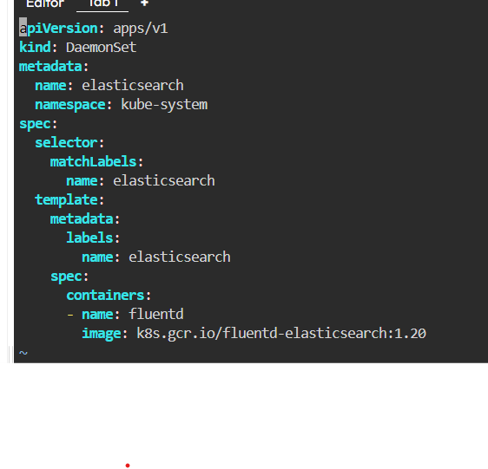

**kubectl apply -f fluentdd.yaml**

5- Deploy a pod named nginx-pod using the nginx:alpine image with

the labels set to tier=backend.

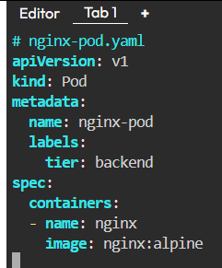

**kubectl apply -f nginnxpod.yaml**

6- Deploy a test pod using the nginx:alpine image.

**kubectl run test --image=nginx:alpine --restart=Never**

7- Create a service backend-service to expose the backend

application within the cluster on port 80.

**kubectl expose pod nginx-pod --name=backend-service --port=80 --target-port=80**

8- try to curl the backend-service from the test pod. What is the response?

**kubectl exec -it test -- sh**

**curl backend-service**

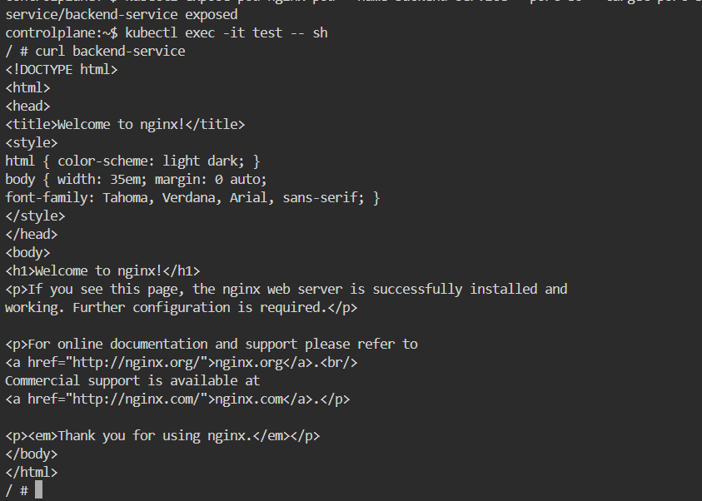

9- Create a deployment named web-app using the image nginx with 2

replicas

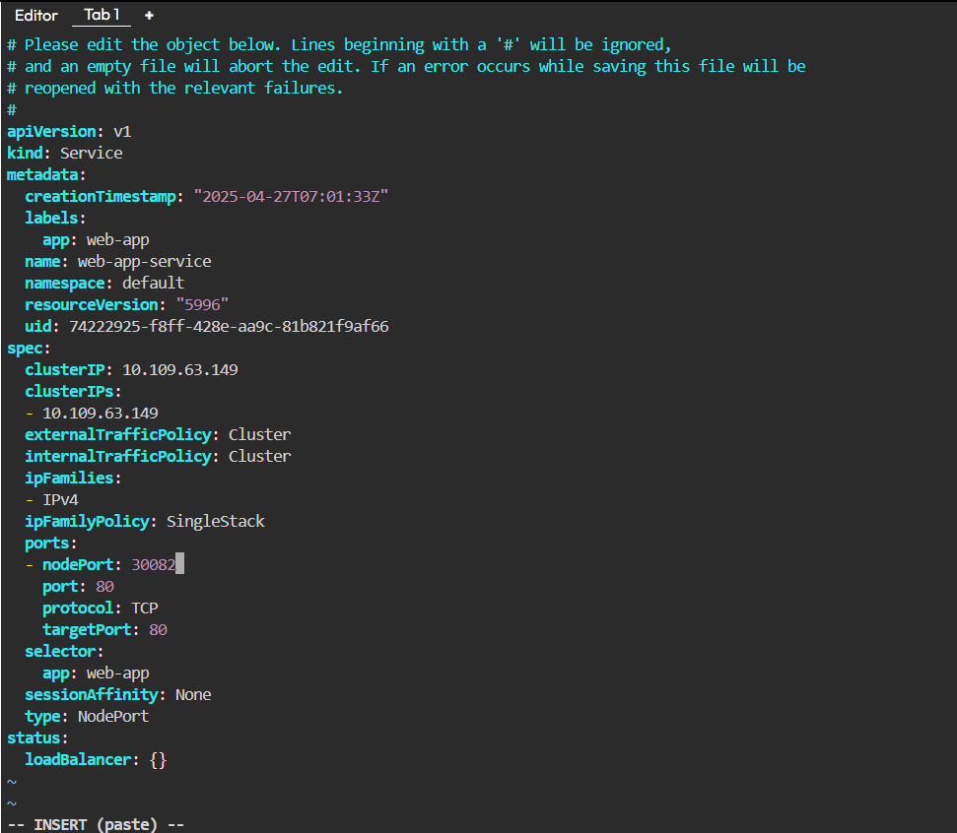10- Expose the web-app as service web-app-service application on

port 80 and nodeport 30082 on the nodes on the cluster

11- access the web app from the node

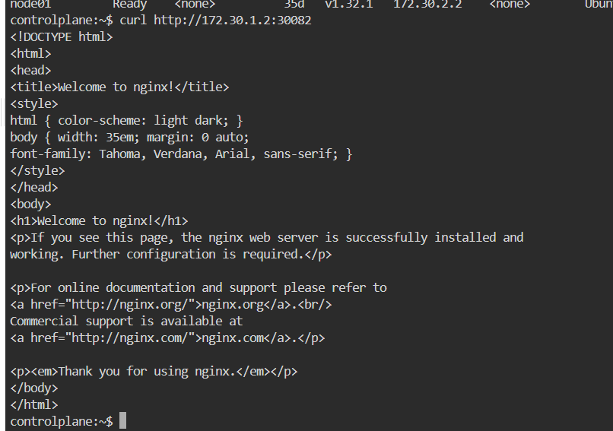

12- How many static pods exist in this cluster in all namespaces?

13-On which nodes are the static pods created currently?

**kubectl get pods --all-namespaces -o wide**